**RAID 6**

RAID 6, also known as double-parity [RAID](https://searchstorage.techtarget.com/definition/RAID) (redundant array of independent disks), is one of several RAID schemes that work by placing data on multiple disks and allowing input/output ([I/O](https://whatis.techtarget.com/definition/input-output-I-O)) operations to overlap in a balanced way, improving performance. Not all types of RAID offer redundancy, although RAID 6 does.

### **How RAID 6 works**

RAID 6 uses two [parity](https://searchstorage.techtarget.com/definition/parity) [stripes](https://searchstorage.techtarget.com/definition/RAID-0-disk-striping), the practice of dividing data across the set of hard disks or SSDs, on each [disk](https://searchstorage.techtarget.com/definition/hard-disk). It allows for two disk failures within the RAID set before any [data](https://searchdatamanagement.techtarget.com/definition/data) is lost.

In a conventional RAID, data is stored in different places on multiple hard disks, thereby increasing the aggregate mean time between failures ([MTBF](https://whatis.techtarget.com/definition/MTBF-mean-time-between-failures)) and improving the fault-tolerance. In the approach known as [RAID 4](https://searchstorage.techtarget.com/definition/RAID-4-redundant-array-of-independent-disks), the number of bits in data blocks on multiple disks is added up, and the total is kept on a disk called the parity disk. If a drive fails, data recovery is facilitated by using the bits stored on the parity disk and bits remaining on the surviving drives. In [RAID 5](https://searchstorage.techtarget.com/definition/RAID-5-redundant-array-of-independent-disks), the parity information is stored diagonally across all the disks in the RAID set. If a single drive fails, the original data is calculated from the parity information remaining on the surviving disks in the set.

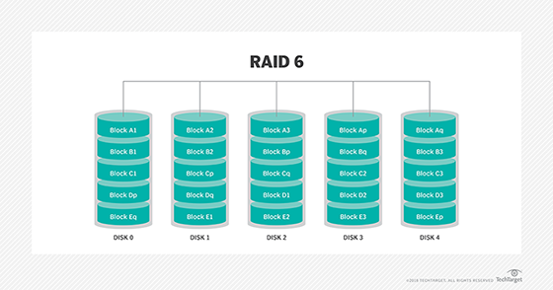

### **Benefits of RAID 6**

RAID 6 offers very high fault- and drive-failure tolerance and can be used for environments that need long [data retention](https://searchstorage.techtarget.com/definition/data-retention) periods, such as [archiving](https://searchdatabackup.techtarget.com/definition/data-archiving). RAID 6 uses less storage than, for example, a RAID 10 array, which can only store half of its total storage capacity in data, as the other half is used by mirroring.

If a [RAID 6 array](https://searchstorage.techtarget.com/tip/Erasure-codes-The-foundation-of-RAID-6-arrays) contains the minimum number of disks -- four -- then it can only hold half the total disk capacity in data, as well, because RAID 6 reserves the capacity amount of two drives to hold parity. The difference comes as disks are added.

The percentage of usable capacity increases as disks are added to a RAID 6 array. If eight disks are used in RAID 6, for example, [parity](https://searchstorage.techtarget.com/definition/parity) -- a technique that checks whether data has been lost or written over when it is moved from one place in storage to another or when it is transmitted between computers -- only consumes 25 percent of the disk capacity. A RAID 10 array dedicates half its capacity to protection, regardless of how many disks are used.

### **Disadvantages of RAID 6**

Each set of parities must be calculated separately using RAID 6. This slows write [performance](https://whatis.techtarget.com/definition/performance). RAID 6 is also more expensive because of the two extra disks required for parity. RAID controller coprocessors are often employed to handle parity calculations and to improve RAID 6 write speed.

It takes a long time to rebuild the array after a disk failure because of RAID 6's slow write times. With even a moderate-sized array, rebuild times can stretch to 24 hours.

RAID 6 requires special hardware; it is important to use a controller specifically designed to support it.

### **Applications of RAID 6**

The ability of RAID 6 to tolerate simultaneous failures without loss of user data makes RAID 6 a better choice than RAID 5 for [mission-critical applications](https://searchitoperations.techtarget.com/definition/mission-critical-computing), such as in the healthcare, banking and defense sectors. When two drives fail with RAID 5, the user suffers data loss. A RAID 6 system, however, protects user data when two drives fail simultaneously.